
LOYOLA JESUIT SECONDARY SCHOOL
2026 FORM FOUR MOCK EXAMINATION
BIOLOGY
PAPER I
(100 Marks)
Tuesday 10th February, 2026 Subject Number:M022/1
Time Allowed: 2Hours

Instructions:

Question  Number | Tick if  answered | Do not write in these columns
1
2
3
4
5
6
7
8
9
10
11
12
13
14
Total
- This paper contains 12 printed pages
Please check.

- Answer all 14 questions in this question paper

- The maximum number of marks is indicated against each question.

- Write your answers in the spaces provided

- Write your ID Number at the
Top of this page and every sheet used.

- In the table provided on this page, tick
against each question you have answered.

- You should hand in your examination paper to
the invigilator when the time is called to stop.

Turnover

SECTION A (70 Marks)
Answer all questions in this section

- (a) Mention any two examples of biotechnology in plants.
_____________________________________________________________________________________________________________________________________ (2 Marks)
(b) Briefly explain how the following plant tissues are used for transport in plants
Xylem_________________________________________________________________________________________________________ (2 Marks)
Phloem_________________________________________________________________________________________________________ (2 Marks)
(c) State any two types of tropisms in plants.
_______________________________________________________________________________________________________________ (2 Marks)
(d) Define the following terms as used in Biology
i.Tropisms_______________________________________________________________________________________________________ (1 marks)
ii.Auxins_________________________________________________________________________________________________________(1 mark)

- Figure 1 Shows a digestive structure found in the small intestines. Use it to answer the questions that follow.
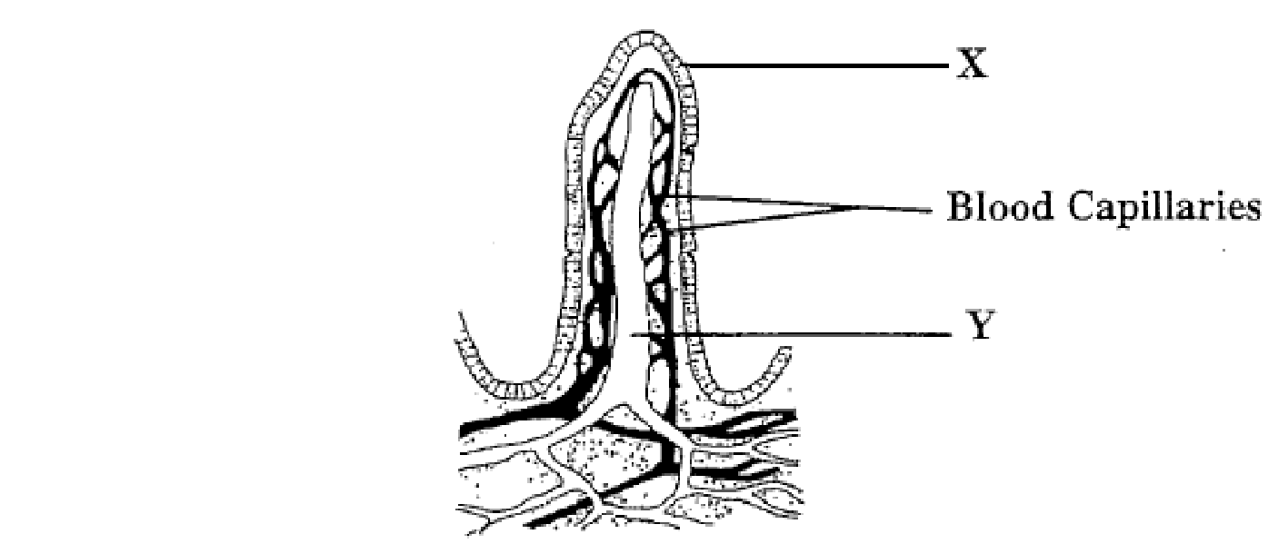

Figure 1
- Identify the structure.
_____________________________________________________ (1 mark)
- What is the part labelled Y and its function?
Y ___________________________________________________ (1 mark)
Function _________________________________________________________________________________________________________________ (1 mark)
- Why the function stated in 2 (b) above can not be performed by the blood capillaries
________________________________________________________________________________________________________________ (1 marks)
- What function of small intestines does the structure named in 2. (a) above fulfill?
_____________________________________________________ (1 mark)
- a. Identify the system of the body that is mostly affected by the following;
- Cholera_____________________________________________________ (1mark)
- Leprosy____________________________________________________ (1 mark)
b. State any two signs of common cold
(i)_____________________________________________________________________
(ii)_______________________________________________________________(2marks)
- Pure red variety of beans were crossed with pure white beans. All the F1 beans were red. Use R for the dominant allele and r for recessive allele
- Give the possible genotypes of the two parents and the F1 plants.
___________________________________________________________________________________________________________________________________________________________________ (3 marks)
- If F1 offsprings were crossed against themselves, write down results of such cross diagram showing the genotypes and phenotypes of the offsprings.

(4 Marks)
(c) If F2 had 288 offspring, how many of them were white? Show yor work
________________________________________________________________________________________________________________ (2 Marks)
- Figure 2 below shows the longitudinal section of the kidney. Use it to answer the questions that follow.
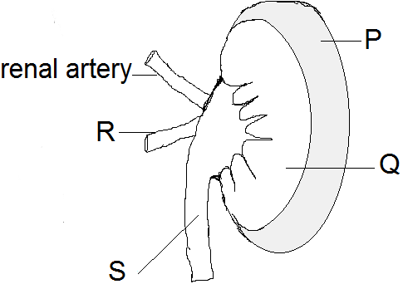
Figure 2
- Name the parts labeled R and S
R ___________________________________________________________
S ___________________________________________________ (2 marks)
- What part of a nephron is found in each part labeled P and Q
P___________________________________________________________
Q __________________________________________________ (2 marks)
- Describe renal failure.
________________________________________________________________________________________________________________ (2 marks)
- a. State one effect of Hyperthyroidism and Hypothyroidism of Thyroxine in humans.
Hyperthyroidism________________________________________________________________________________________________________________________________Hypothyroidism_________________________________________________________________________________________________________________________ (2 marks)
b. Briefly explain one functional similarity between nervous and endocrine systems.
____________________________________________________________________
_____________________________________________________________ (1 mark)
- Figure 3 shows hormone levels in the blood of a woman and thickening of uterine wall. Use it to answer the questions that follow.
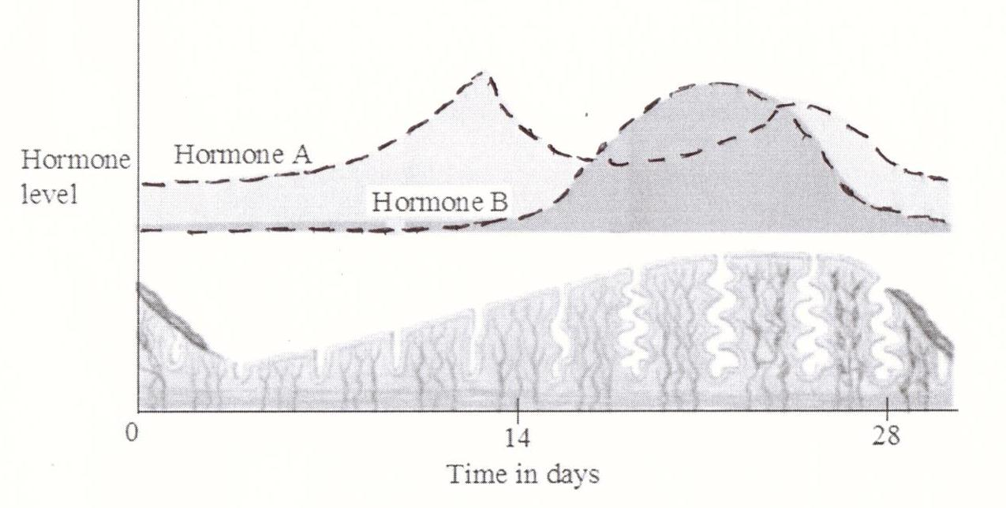
Figure 3
- (i). Which hormone represent Oestrogen?
_____________________________________________________________ (1 mark)
(ii). Give a reason for your answer to 7. a (i) above.
_________________________________________________________________________________________________________________________________ (1 mark)
- What structure produces progesterone in the ovary?
_____________________________________________________________ (1 mark)
- What happens when the level of progesterone hormone drops in the blood?
_____________________________________________________________ (1 mark)
- Mention two ways of preventing maternal mortality.
- ______________________________________________________________________________________________________________________________
- ______________________________________________________________________________________________________________________ (2 marks)
- a. What does the term vaccination mean as used in biology?
___________________________________________________________
_________________________________________________________ (1 mark)
b. Give the difference between natural active immunity and artificial active immunity.
______________________________________________________________________________________________________________________________________ (2 marks)
c. How does the following first line defense work?
i) Symbiotic defense
______________________________________________________________________________________________________________________________________ (2 marks)
ii)Tears________________________________________________________________________________________________________________________________ (2 marks)
d. Mention any two factors to consider before organ transplant
______________________________________________________________________________________________________________________________________ (2 marks)
- Figure 4 shows one of the nutrient cycles in an ecosystem
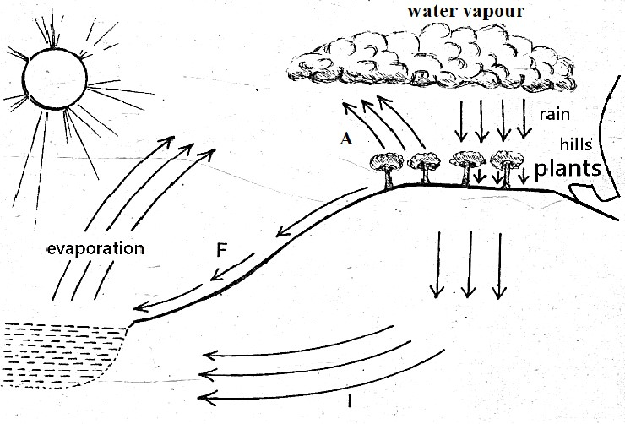
Figure 4
- What processes are represented by A and F?
A ___________________________________________________________________
F ___________________________________________________________ (2 marks)
- If all trees were removed in the cycle in Figure 4, what would happen?
__________________________________________________________________________________________________________________________________ (2 marks)
- Figure 5 is a graph showing results of an experiment conducted using a potted plant. Use it to answer the questions that follow.

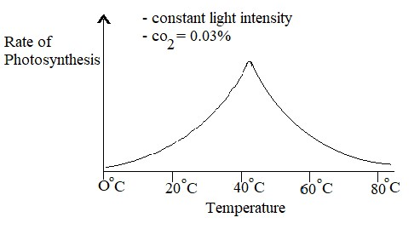
Figure 5
- What was the aim of this experiment?
_______________________________________________________________________________________________________________________________ (1 mark)
- (i) Mention the optimum temperature for the rate of photosynthesis.
___________________________________________________________ (1 mark)
(ii) Give a reason for your answer in 10.b (1) above
______________________________________________________________________________________________________________________________________ (1 mark)
c. Account for the graph from 0ºC to 80ºC
______________________________________________________________________________________________________________________________________ (2 marks)
d. Describe any two factors that affect the rate of transpiration in a growing plant.
(i)___________________________________________________________________________________________________________________________________ (2 Marks)
(ii)__________________________________________________________________________________________________________________________________ (2 Marks)
- Figure 3 is a graph showing the population of the bacteria and amount of oxygen in South Rukuru river soon after sewage was discharged into it. Use it to answer the questions that follow.
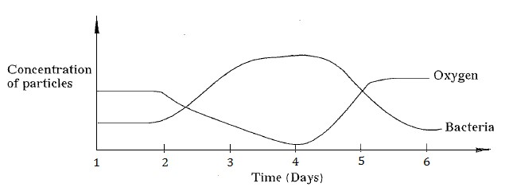
Figure 3
- What type of pollution is represented by the graph in Figure 3? __________________________________________________ (1 mark)
- Describe the amount of oxygen between day 2 and day 5. ___________________________________________________________________________________________________________________________________________________________________ (2 Marks)
- What is the role of Bacteria in the nutrient cycles?
________________________________________________________________________________________________________________ (2 marks)

SECTION B (30 MARKS)
Answer all the three questions in this section. Your answer should be in an essay form.

- Explain five ways of preventing Cholera.
________________________________________________________________________________________________________________________________________________________________________________________________________________________________________________________________________________________________________________________________________________________________________________________________________________________________________________________________________________________________________________________________________________________________________________________________________________________________________________________________________________________________________________________________________________________________________________________________________________________________________________________________________________________________________________________________________________________________________________________________________________________________________________________________________________________________________________________________________________________________________________________________________________________________________________________________________________________________________________________________________________________________________________________________________________________________________________________________________________________________________________________________________________________________________________________________________________________________________________________________________________________________________ (10 Marks)

- Explain any five evidences of evolution.
______________________________________________________________________________________________________________________________________________________________________________________________________________________________________________________________________________________________________________________________________________________________________________________________________________________________________________________________________________________________________________________________________________________________________________________________________________________________________________________________________________________________________________________________________________________________________________________________________________________________________________________________________________________________________________________________________________________________________________________________________________________________________________________________________________________________________________________________________________________________________________________________________________________________________________________________________________________________________________________________________________________________________________________________________________________________________________________________________________________________________________________________________________________________________________________________________________________________________________________________________________________________________________________________________________________________________________________________________________________________________________________________________________________________________________________________________________________________________________________________________________________________________________________________________(10 Marks)

- Explain any five adaptations of leaves for the process of photosynthesis.
_______________________________________________________________________________________________________________________________________________________________________________________________________________________________________________________________________________________________________________________________________________________________________________________________________________________________________________________________________________________________________________________________________________________________________________________________________________________________________________________________________________________________________________________________________________________________________________________________________________________________________________________________________________________________________________________________________________________________________________________________________________________________________________________________________________________________________________________________________________________________________________________________________________________________________________________________________________________________________________________________________________________________________________________________________________________________________________________________________________________________________________________________________________________________________________________________________________________________________________________________________________________________________________________________________________________________________________________________________________________________________________________________(10 Marks)

END OF QUESTION PAPER

